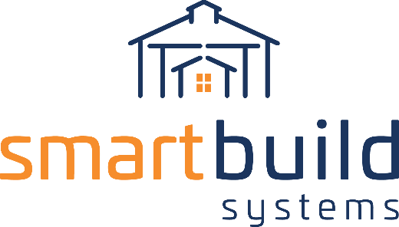
AUTHORIZED DISTRIBUTORS

CONTRACTOR EMAIL COPY

Our exciting new partnership aims to grow your business!

We are thrilled to announce we teamed up with SmartBuild Systems to help you save time building out your estimates.

SmartBuild developed the construction industry’s only complete design system for Post Frame buildings and has increased deal close rates by 50% for many contractors!

Reduce errors and the cost of doing business by automatically generating takeoffs, bids, 3D models, cut lists, construction drawings, and sales documents for almost any post frame building, then submitting those orders to us with the push of a button.

Contact us [contact link] for a demo and to discuss getting set up on our proprietary platform.

Sincerely,

[Company Representative]
[Your Company]
[Phone Number]
[Email Address link]

