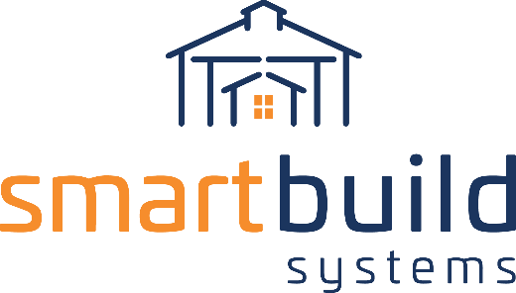
AUTHORIZED DISTRIBUTORS

PRESS RELEASE COPY

[Your Company] and SmartBuild Systems Announce Partnership
Offering Cutting Edge Software for Post Frame

[City, ST] – [Date] – [Your Company] [Short Description of your company – i.e. the pole barn industry’s leader in XXX] and SmartBuild Systems, the construction industry’s only complete design system for Post Frame buildings, announced today a partnership that could decrease the time contractors spend closing deals by 60%.

[Your Company] contractors will use SmartBuild to automatically generate takeoffs, bids, 3D models, cut lists, construction drawings, and sales documents for almost any post frame building then submit those orders to [Your Company] with the push of a button.

[Begin Quote i.e. - “This is great news for [Your Company] and all of our contractors” said [Your Company] [Company Representative] [Continue Quote ”with this partnership in place, we’ll help all our contractors be more successful.”]

SmartBuild CEO Keith Dietzen is also excited about the partnership. [“Your Company] enjoys an excellent reputation that is well deserved. We have gained an appreciation for the depth of their knowledge and the care they exercise on behalf of their customers. Together, [Your Company] and SmartBuild are giving the industry the system it has always needed. We are proud to bring SmartBuild to market with [Your Company.”]

About [Your Company]
[Company Info] LEARN MORE at [Your Website Link]

About SmartBuild Systems
SmartBuild Systems is the pole barn industry’s only complete design system for Post Frame
structures. Simple enough for anyone to use, this web-based software quickly generates a 3D model, material lists, pricing, proposals, and construction documents for almost any Post Frame building. SmartBuild is built out of the Keymark Enterprises shop, a leading developer of software technologies for the construction industry since 1975. LEARN MORE at https://smartbuildsystems.com/

CONTACT

[Company Representative]
[Your Company]
[Phone Number]
[Email Address link]

Keith Dietzen
SmartBuild Systems
303-579-6277
kdietzen@keymark.com

