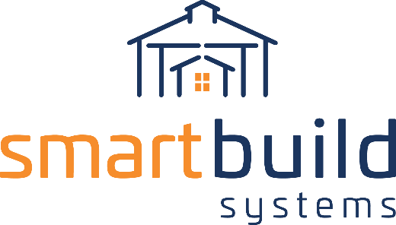
AUTHORIZED DISTRIBUTORS

SOCIAL MEDIA COPY
We recommend linking your social post to the page of your website where you’ve placed information about SmartBuild, or to a blog post or press release announcing our new partnership.

Twitter - #contractors 👷 increase your deal close rate, decrease time spent on sales & reduce the cost of doing business with our automated system for #polebarn #postframe #construction! Contact us to learn more about our new partnership with @SmartBuildSys! ⬇⬇

All other social channels - #contractors 👷 if you’re ready to increase your deal close rate, decrease time spent on each sale, and dramatically reduce the cost of doing business – we’re ready to set you up on our automated system for #polebarn #postframe #construction! Contact us to learn more about our new partnership with #SmartBuildSystems! ⬇⬇

For Facebook @mentions - @smartbuildsystems

