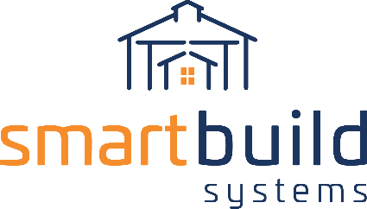
LANDING PAGE COPY

INSTRUCTIONS:
To maximize your partnership with SmartBuild, we recommend you set up a page on your website where your contractors can learn about the software and begin to use it. To make this as easy as possible, we drafted copy for you (below).

SUGGESTED URL: https://www.YOURURL.com/smartbuild

HEADLINE:
SMARTBUILD SYSTEMS.
BID FASTER. WORK SMARTER. WIN MORE BUSINESS.

SUB-HEADLINE:
Increase your bottom line with instant quotes and push-button ordering.

BODY COPY:
You can now access your very own 3D design tool right from your laptop!
With SmartBuild, it’s easy to model post frame buildings - in real-time - with your clients. Simply use the menu-driven set of prompts to redesign, add features, and recalculate pricing right before the buyers’ eyes. When your happy with the proposal, SmartBuild will automatically create a sales proposal customized for your company. And as a bonus, materials lists and construction drawings for your use.

GET STARTED
[button that links to your version of SmartBuild]

LEARN MORE
[button that links to https://smartbuildsystems.com/]

ADDITIONAL COPY:
As our building partner, we’ll set you up with our proprietary platform complete with our entire in-house inventory database and part-number system, as well as standard sales contracts and bid form templates. With SmartBuild, you’ll work as you never could before, handling sales calls in person – in less time than it takes to do a takeoff at the office – leaving more opportunity to grow your business.

GRAPHIC:
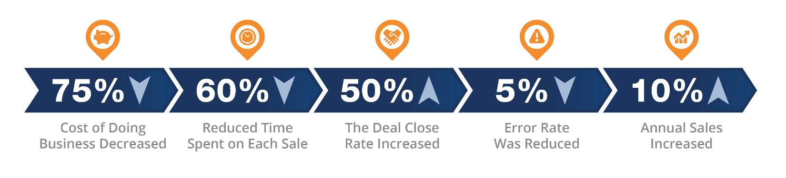
TESTIMONIAL:
[From one of your happy contractors]

