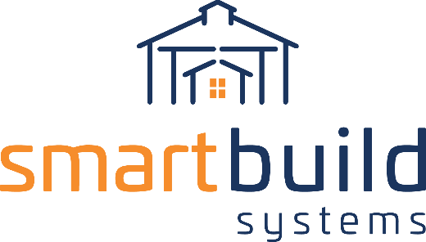
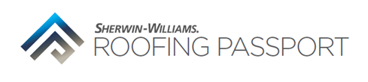

AUTHORIZED DISTRIBUTORS

CONTRACTOR EMAIL COPY

Our exciting new partnership aims to grow your business!

We are thrilled to announce we have teamed up with SmartBuild Systems to save you time building out estimates.

SmartBuild developed the construction industry’s only complete design system for Post Frame buildings and has now teamed up, with EagleView and Sherwin-Williams, to drastically transform the way you work.

The Sherwin-Williams Roofing Passport, built specifically for the metal residential re-roofing market, is a groundbreaking platform that simplifies metal roof estimation and ordering. With the push of a button, this process improves measurement accuracy, eliminates the need to manually measure before submitting an estimate, and saves time and resources – increasing your profitability.

Contact us [contact link] for a demo and to discuss getting set up on our proprietary platform.

Sincerely,

[Company Representative]
[Your Company]
[Phone Number]
[Email Address link]

