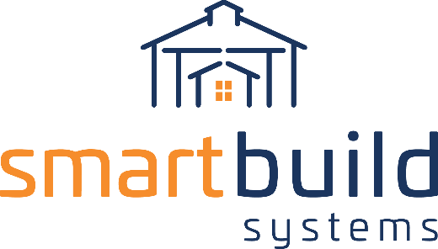

AUTHORIZED DISTRIBUTORS

PRESS RELEASE COPY
[Your Company] and SmartBuild Systems Announce Partnership
Cutting Edge Software for the metal residential re-roofing market

[City, ST] – [Date] – [Your Company] [Short Description – i.e. the metal roofing industry’s leader in this and that] and SmartBuild Systems, a leading automated estimating software developer for the construction industry, announced today a partnership that creates the most accurate metal roofing bids available -- in less than 5 minutes -- via Sherwin-Williams Roofing Passport.

[Your Company] contractors use Roofing Passport to order property measurements, view and edit 3D roof models, retrieve a complete material takeoff list (including ancillary items,) create professional and customized bids, access the material catalogue, then submit orders to [Your Company] with the push of a button.

[Begin Quote i.e. - “This is great news for [Your Company] and for the entire metal roofing industry” said [Your Company] [Company Representative] ] [Continue Quote ”with this partnership in place, we’ll help all our contractors be more successful.”]

SmartBuild CEO Keith Dietzen is also excited about the partnership. [“Your Company] enjoys an excellent reputation that is well deserved. We have been working with them for [time period] and have gained an appreciation for the depth of their knowledge and the care they exercise on behalf of their customers. Together, [Your Company] and SmartBuild are giving the industry the system it has always needed. We are proud to bring Roofing Passport to market with [Your Company.”]

About [Your Company]
[Company Info] LEARN MORE at [Your Website Link]

About Roofing Passport
The Sherwin-Williams Roofing Passport integrates seamlessly with EagleView aerial property measurements, SmartBuild Systems building application software, and Sherwin-Williams Coil Coatings. With this digital platform contractors order a property measurement, gather the required metal roof takeoff data for a lead, and engage a roofing manufacturer – all in one click. This simplified metal roof estimation and ordering process improves measurement accuracy, eliminates the need to manually measure before submitting an estimate, and saves time and resources – increasing profitability.
LEARN MORE at https://smartbuildsystems.com/roofing-passport/

CONTACT

[Company Representative]
[Your Company]
[Phone Number]
[Email Address link]

Keith Dietzen
SmartBuild Systems
303-579-6277
kdietzen@keymark.com

