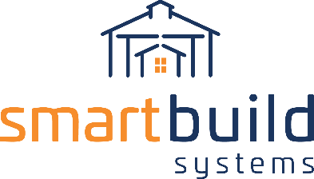

AUTHORIZED DISTRIBUTORS

SOCIAL MEDIA COPY
We recommend linking your social post to the page of your website where you’ve placed information about Roofing Passport, or to a blog post or press release announcing our new partnership.

Twitter - #contractors 👷 in less than 5 minutes, and for as little as $35, create the most accurate #metalroofing bid of your career without ever leaving the office! Contact us to learn more about our new partnership with @SmartBuildSys! ⬇⬇

All other social channels - #contractors 👷 if you’re ready to order a property measurement, gather the required #metalroof takeoff data for a lead, and engage a roofing manufacturer – all in one click – we’re ready to set you up on our automated system for the metal residential re-roofing market! Contact us to learn more about our new partnership with #SmartBuildSystems! ⬇⬇

For Facebook @mentions - @smartbuildsystems

